Packet Tracer - Troubleshoot Connectivity Issues
Step 1: Determine connectivity issues from PC-01.
Ping to default gateway (172.16.1.1): Timeout
To web server (209.165.201.2): Timeout
To PC-02 172.16.1.4: Timeout
To PC-A 172.16.2.3: Timeout
To PC-B 172.16.2.4: Timeout

ns:
access www.cisco.pka: Host Name Unresolved
209.165.201.2: Host Name Unresolved

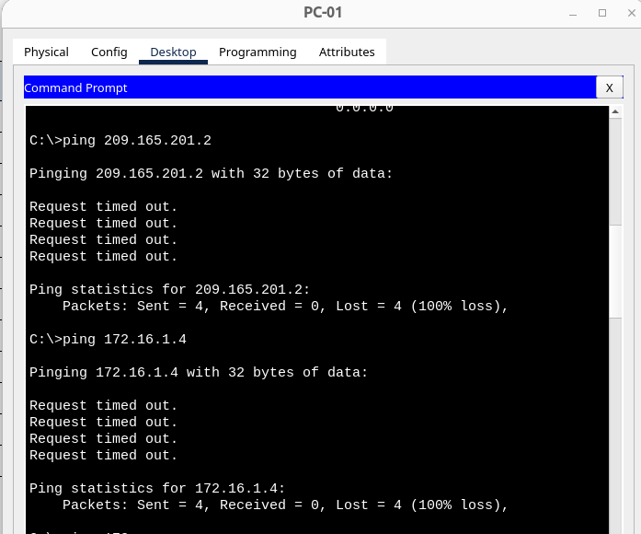
Issue: Wrong Ip address gatweay 172.168.1.3
Action: Change IP gateway to 172.16.1.3
Now we can ping to some other devices.
Ping to default gateway (172.16.1.1): OK
To web server (209.165.201.2): OK
To PC-02 172.16.1.4: OK
To PC-A 172.16.2.3: unreachable
To PC-B 172.16.2.4: unreachable

ns:
access www.cisco.pka: OK
209.165.201.2: OK
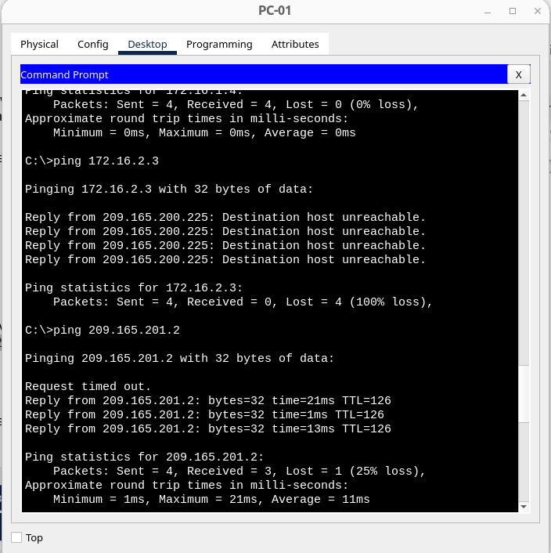
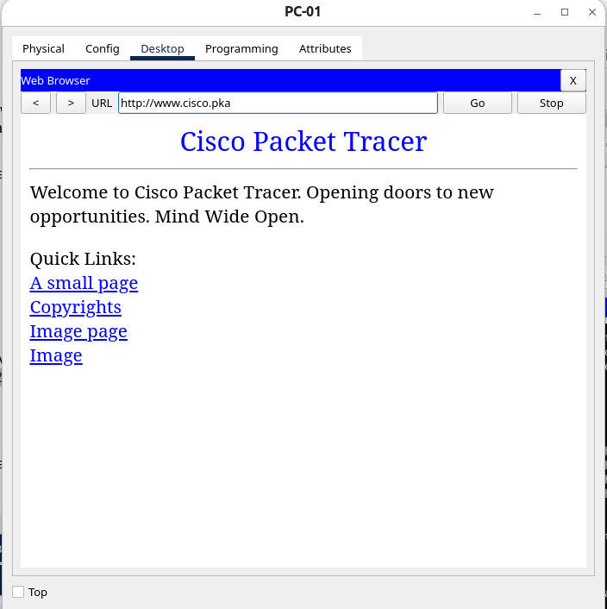
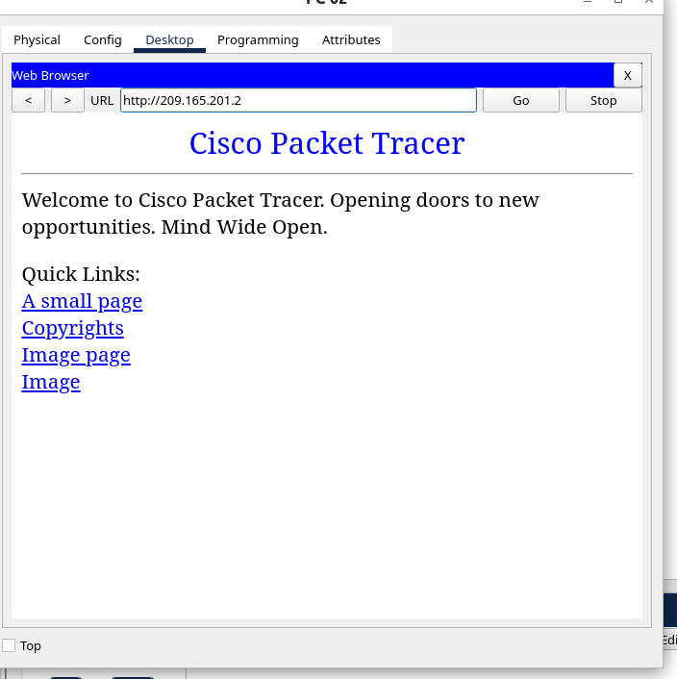
Step 2: Determine connectivity issues from PC-02.
Change IP from 172.16.11.4 to 172.16.1.4
Ping to default gateway (172.16.1.1): OK
To web server (209.165.201.2): OK
To PC-01 172.16.1.3 OK
To PC-A 172.16.2.3: unreachable
To PC-B 172.16.2.4: unreachable

ns:
access www.cisco.pka: OK
209.165.201.2: OK
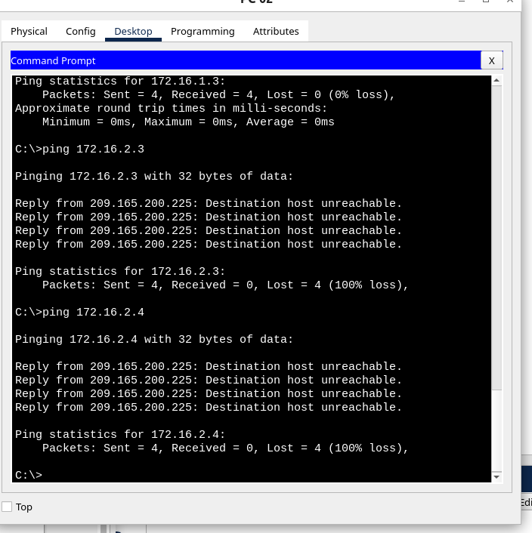

Step 3: Determine connectivity issues from PC-A.
To web server (209.165.201.2)? Timeout
Ping to default gateway (172.16.2.1)? Timeout
Ping to PC-B 172.16.2.4? OK
To PC-01 172.16.1.3? Timeout
To PC-02 172.16.1.4? Timeout
Can PC-A access www.cisco.pka? Unresolved
Using the web server IP address 209.165.201.2? Unresolved
Some devices are not reachable
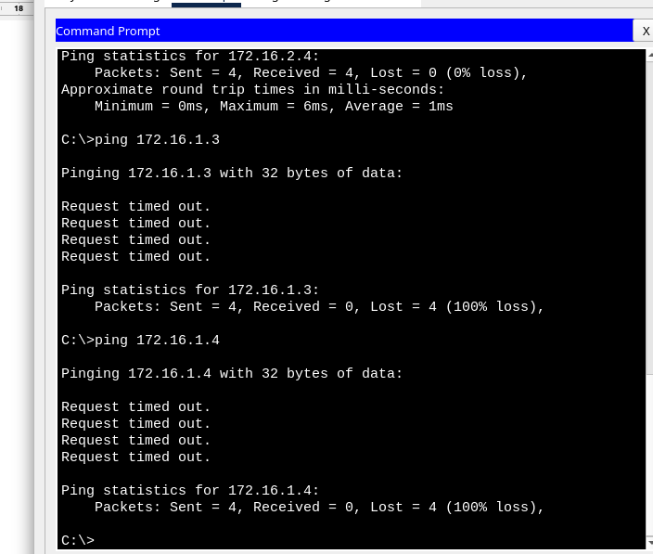
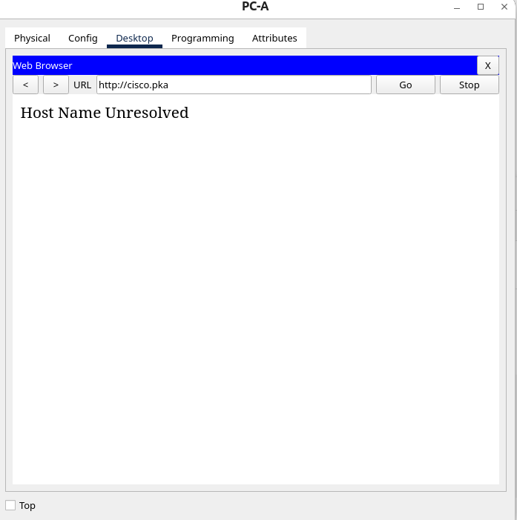

Step 4: Determine connectivity issues from PC-B.
To web server (209.165.201.2)? Timeout
Ping to default gateway (172.16.2.1)? Timeout
Ping to PC-A 172.16.2.3? OK
To PC-01 172.16.1.3? Timeout
To PC-02 172.16.1.4? Timeout
Can PC-A access www.cisco.pka? Unresolved
Using the web server IP address 209.165.201.2? Unresolved
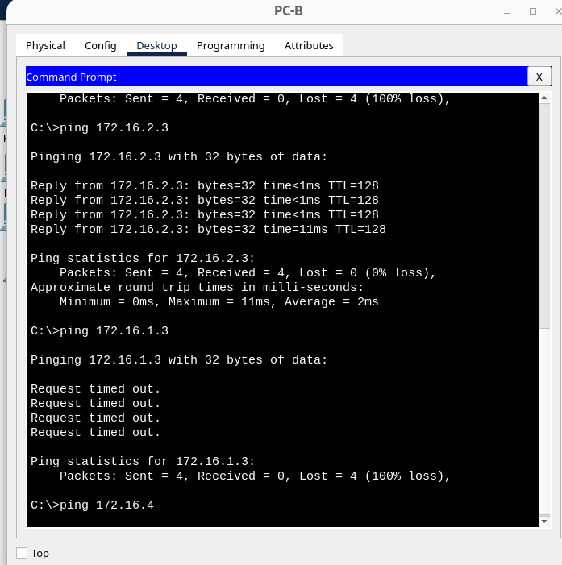
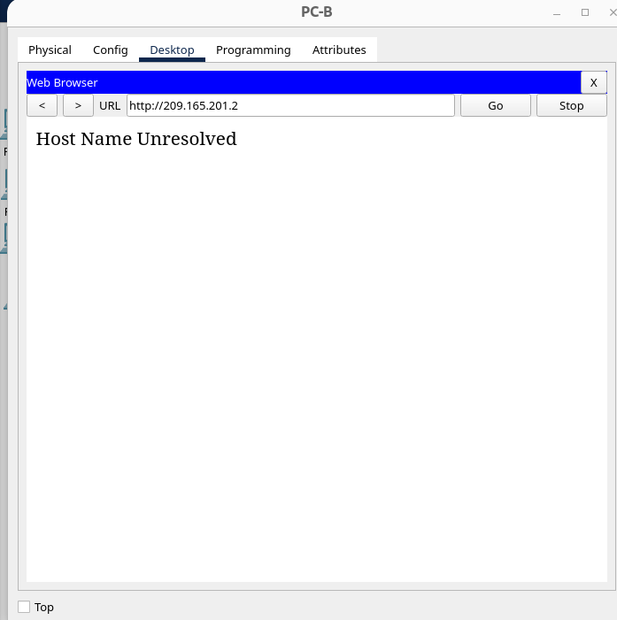
Issue: PC-B cannot reach any other device excep PC-A
Plan action: The connection are broken between R1 and C1/C2, also between R1 ab cisco server. So I will check IP config on R1, then setup DNS2.

Setup DNS2 209.165.201.4:
To web server (209.165.201.2)? NOT
Ping to default gateway (172.16.2.1)? NOT
Ping to PC-A 172.16.2.3? OK
To PC-01 172.16.1.3? NOT
To PC-02 172.16.1.4? NOT
Can PC-A access www.cisco.pka? NOT
Using the web server IP address 209.165.201.2? NOT

Changed to DNS2 did not have any result.
I will try yo change on R1, port G01 172.16.3.1. → 172.16.2.1

from PC-01: connect to R1 to change G01 ip
ssh -l Admin01 172.16.1.1 (password: cisco12345)
conf t
interface gigabitEthernet 0/1
ip address 172.16.2.1 255.255.255.0
no shutdown
exit
exit
exit

Final configuration:
1. PC-A, PC-B: DNS1 = 209.165.201.3
2. R1: G0/1 = 172.16.2.1

Step 5: Verify connectivity.
from PC-01.
To PC-A 172.16.2.3: ok

ns:
To www.cisco.pka: ok
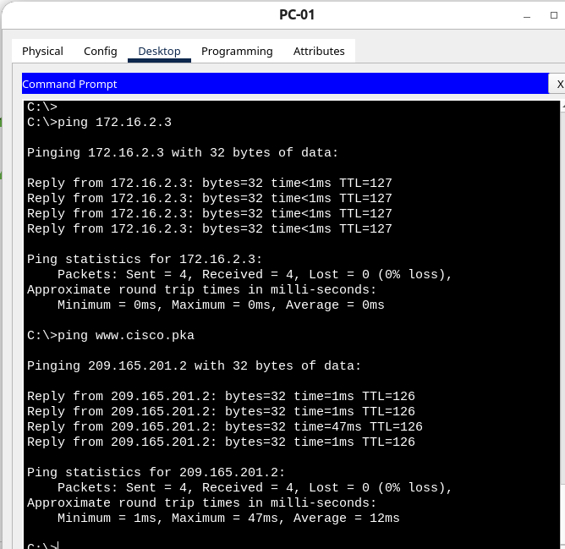

from PC-02.
To PC-A 172.16.2.3: ok

ns:
To www.cisco.pka: ok

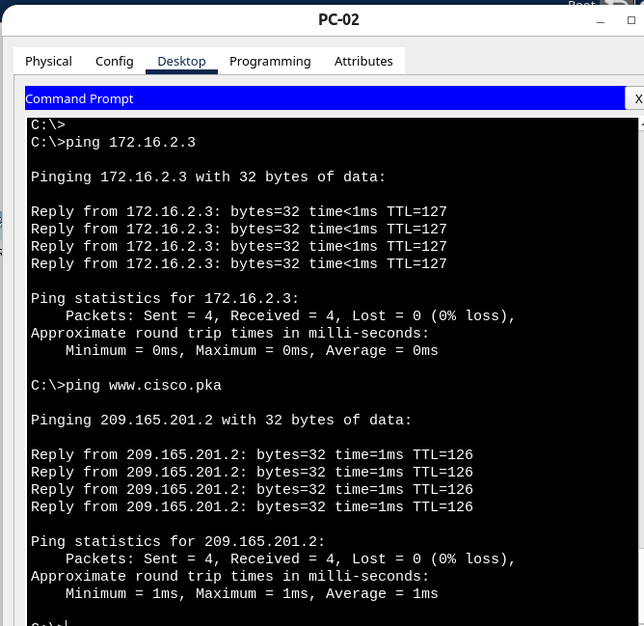
from PC-A.
To web server (209.165.201.2)? ok
Ping to default gateway (172.16.2.1)? Timeout
To PC-01 172.16.1.3? Timeout
To www.cisco.pka:
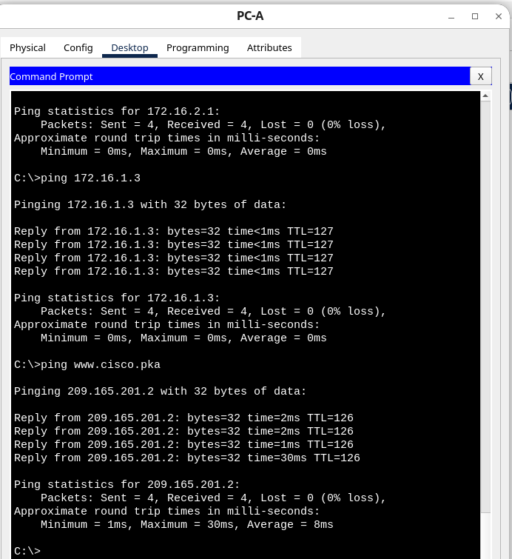

from PC-B.
To web server (209.165.201.2)?
Ping to default gateway (172.16.2.1)?
To PC-01 172.16.1.3?
To www.cisco.pka:
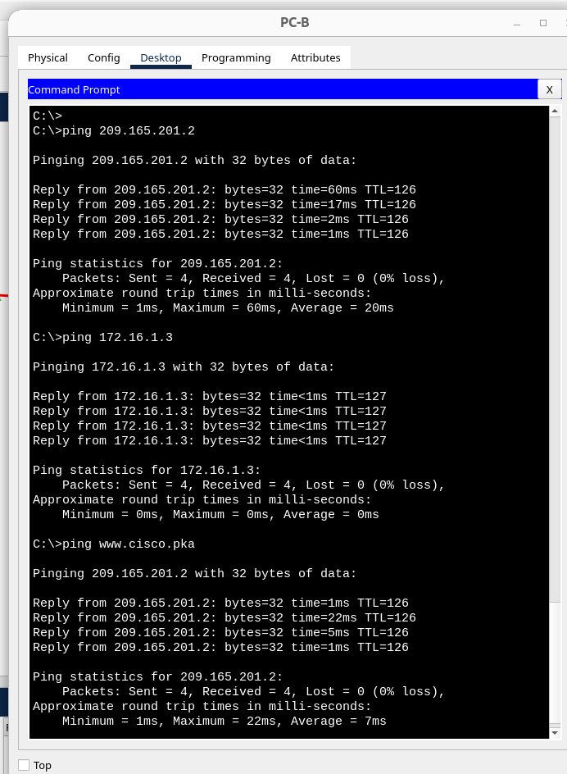

Suggested Scoring Rubric
Activity Section | Possible Points | Earned Points
1d | 5 | 5
2d | 5 | 5
3d | 5 | 5
4d | 5 | 5
Packet Tracer | 15 | 15
Total Score | 35 | 35

Network & Packet tracer test connection results:
